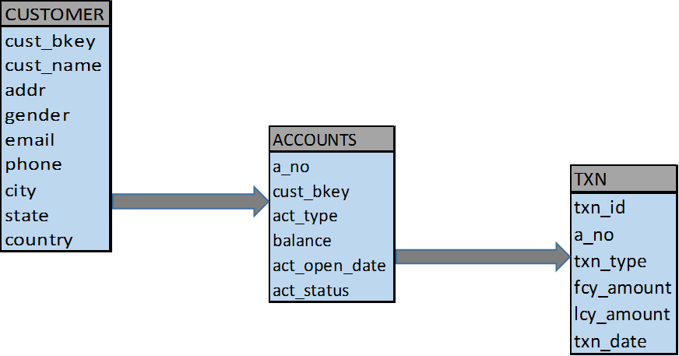

SQL Questions:

1. Write a query to display all the customer names who do not have a phone
2. Write a query to display all the customers and the number of accounts they hold
3. Display the customer who have the highest balance across all account types
4. Display the customer name who have the highest balance in individual account types
5. Display the State wise no of accounts opened in the previous year
6. Display the customers who hold more than 2 accounts of the same type
7. Display customer name and transaction type wise transaction amounts. (Consider two types of transactions which are Debit and Credit)
8. Display city wise no of male and female customers
9. Display the customers who has only savings accout.
10. Display the customerwise total deposit amount and total withdraw amount

Customer Deposit_amt Withdraw_amt

1. Display the cities that have more number of customers than the city HYD.
2. Display customers who have more number of accounts than customer ‘MIKE’.
3. Display the common customers who made transactions in the current and previous month.
4. Display statewise no of accounts and no of transactions in the current year.
5. Display customers who have their email in gmail domain.
6. Display the youngest customer in each city.
7. Display the account type wise no of customers and no of accounts opened in the current year.
8. Display the customers who opened an account on birth day.